FUNDAMENTALS OF DATA LITERACY WITH TABLEAU

Project title:

Subscribers Galore: Exploring World’s Top YouTube Channels

Team id:

NM2023TMID09415

Team lead id:

036DF011915450FBCBA437408C97FF10

Team member’s id:

587E9449AEA9D69BEF64582A6A096BDB

CE7ACADE103FB408B544749519F8E85C

BA2EBC1D9175A8684CC48D2CE210B95D

Project Report

1. Introduction:

A subscriber to a channel on the video-sharing YouTube is a user who has chosen to receive the channel's content by clicking on that channel's "Subscribe" button, and each user's subscription feed consists of videos published by channels to which the user is subscribed. The ability to subscribe to users was introduced in October 2005. YouTube began publishing a list of its most- subscribed channels in April 2006. An early archive of the list dates to May 2006.

The following table lists the 50 most-subscribed YouTube channels, as well as the primary language and content category of each channel. The channels are ordered by number of subscribers; those whose displayed subscriber counts are identical are listed so that the channel whose current growth rate indicates that its displayed subscriber count will exceed that of the other channel is listed first. Automatically generated channels that lack their own videos (such as Music and News) and channels that have been made effectively obsolete as a result of the transferal of their content (such as Justin Bieber VEVO and Taylor Swift VEVO) are excluded. As of February 2023, 21 of the 50 channels listed primarily produce content in English while 16 primarily produce content in Hindi. All 50 of the channels have surpassed 40 million subscribers, 39 of them have surpassed 50 million subscribers, 23 of them have surpassed 60 million subscribers, 16 of them have surpassed 70 million subscribers, 12 of them have surpassed 80 million subscribers, 10 of them have surpassed 90 million and 7 of them have surpassed 100 million subscribers. Only 1 channel (T-Series) has surpassed 200 million subscribers

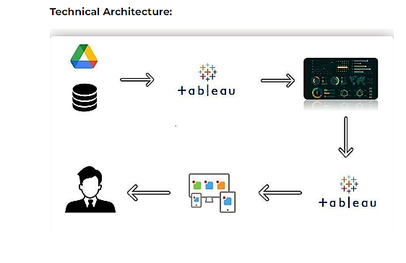

Purpose:

This project helps us to analyze the data. It make us to be skilled in future for our job carriers.

2. Problem definition and design thinking:

* Empathy map

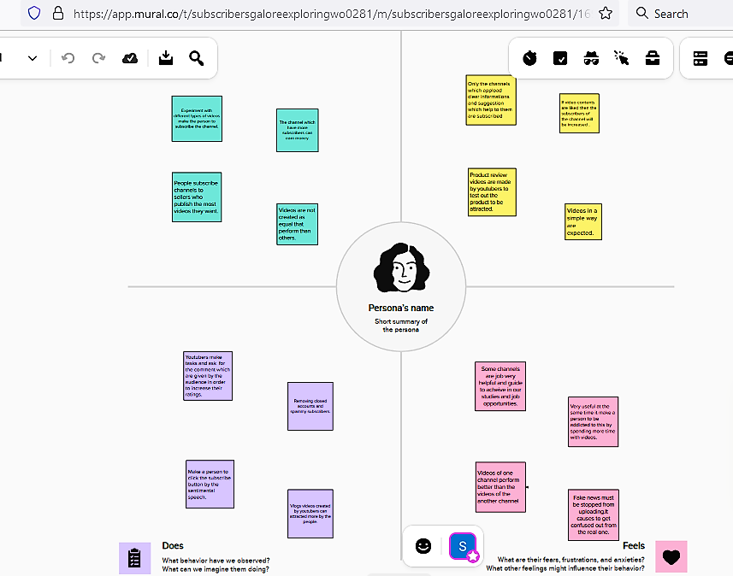

* Brainstorming map

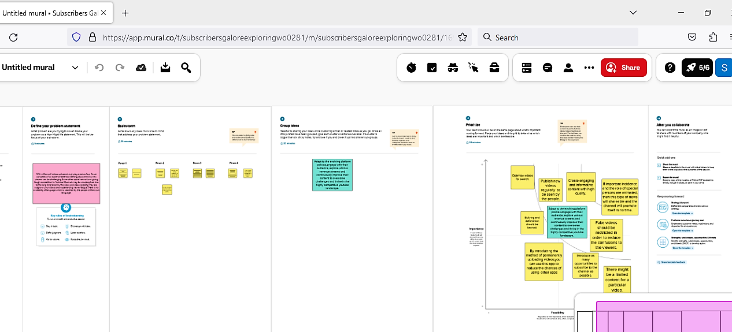

3. Result:

Data visualizations

Rank wise channels

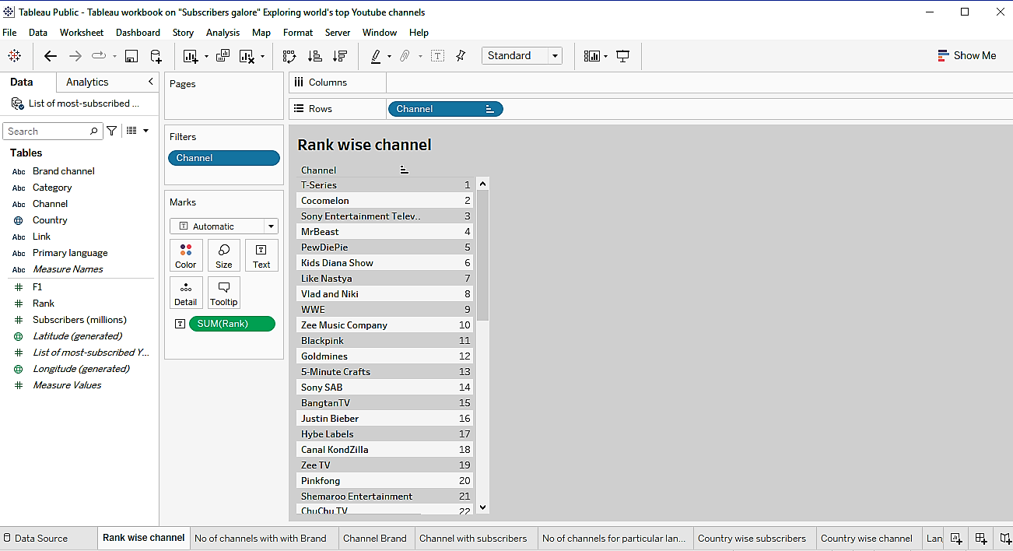

No of channels with brand

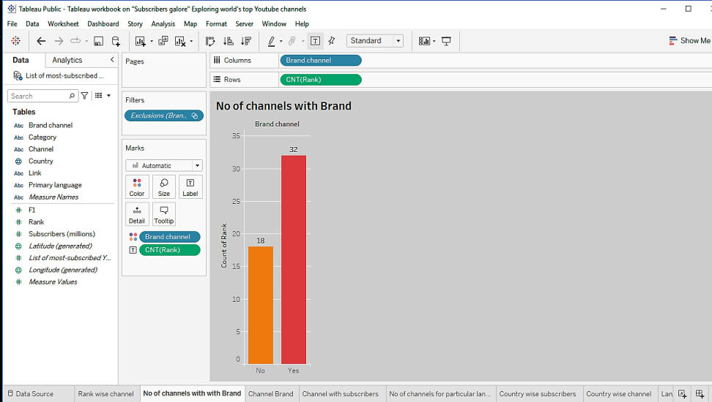

Channel brand

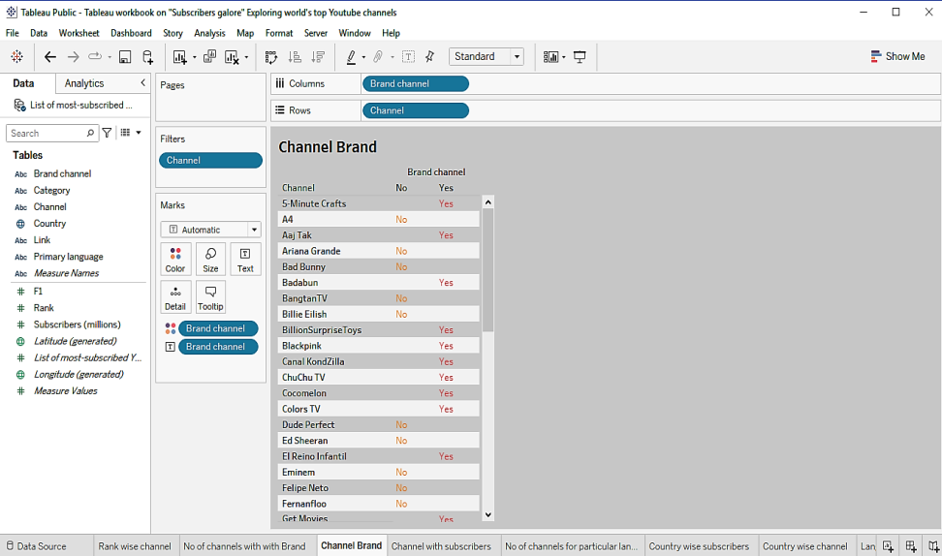

Channel name with subscribers

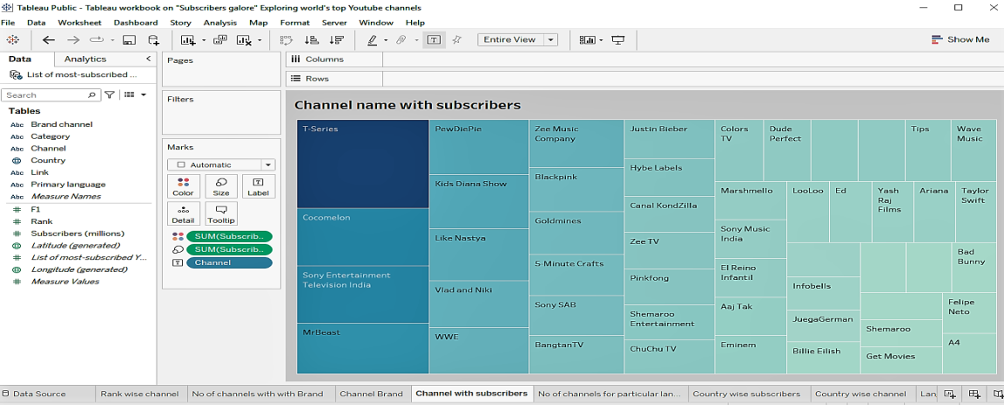

No of channels for particular language

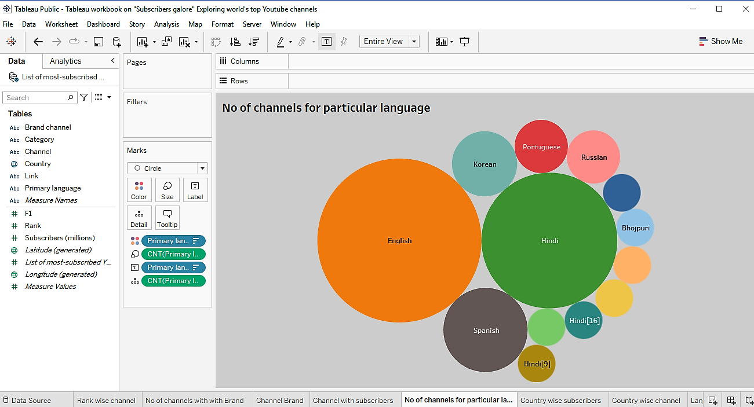

Country wise subscribers

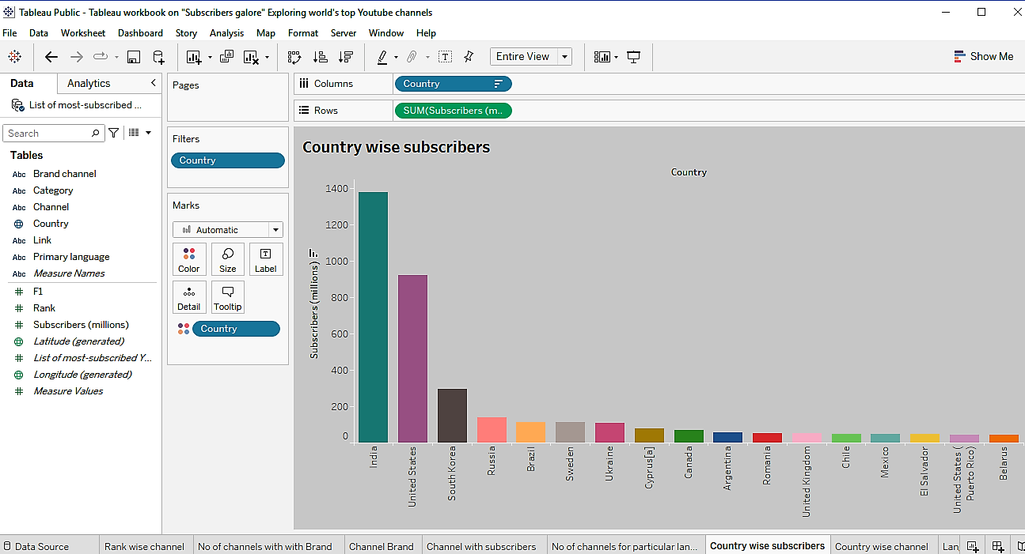

Language wise subscribers

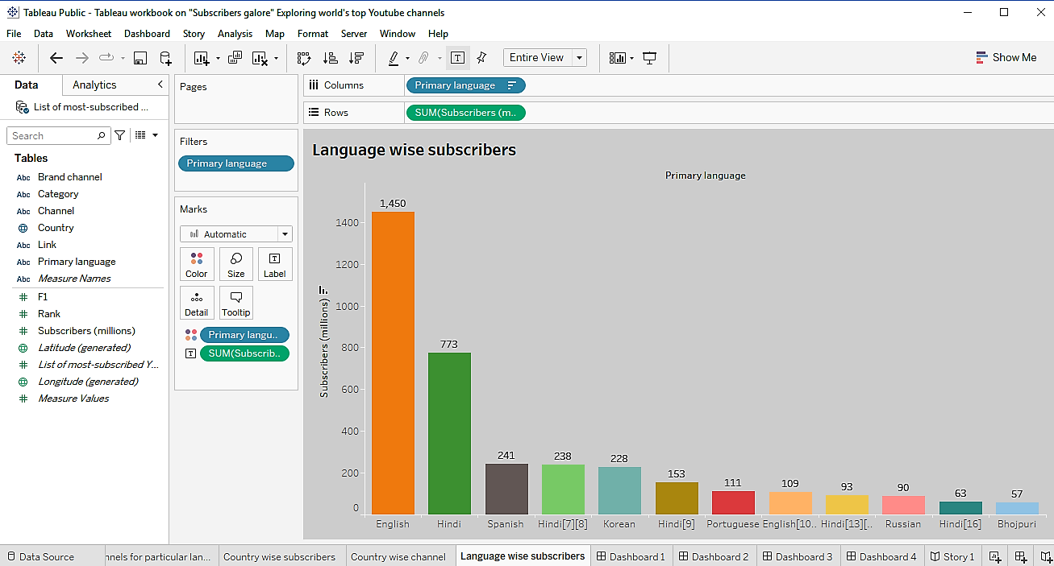

Country wise channel

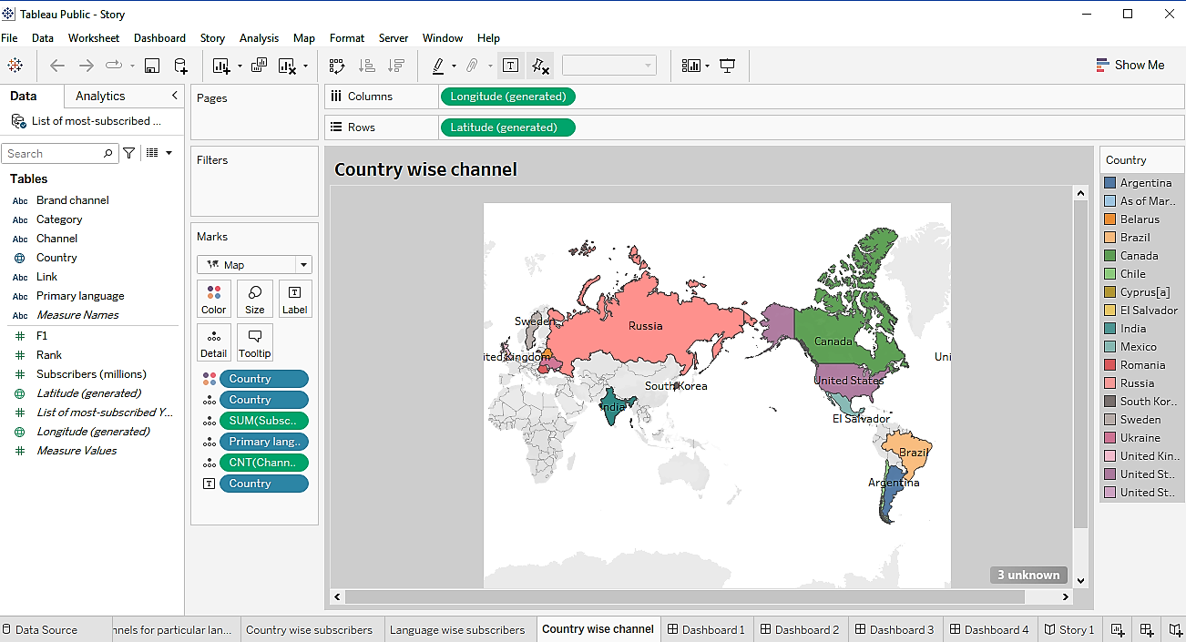

Dashboards

Rank wise channel, No of channel with brand and Channel brand

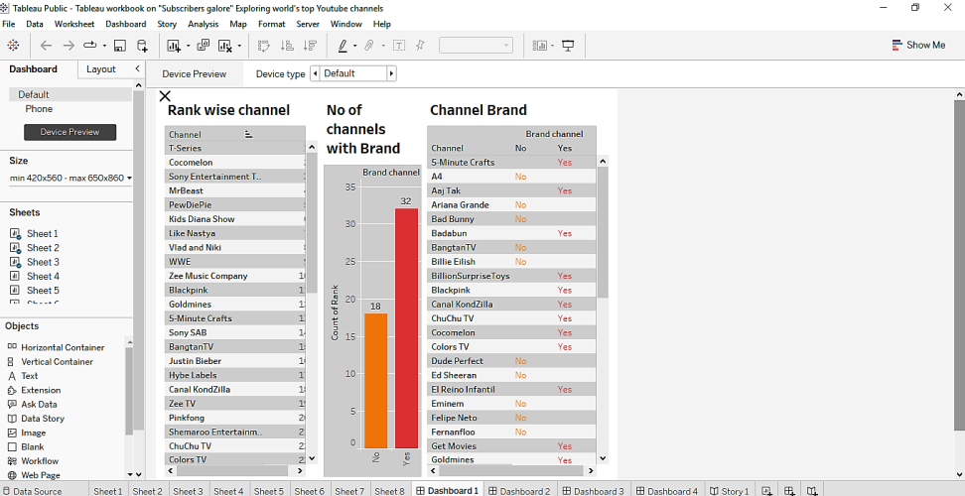

Channel name with subscribers and No of channels for particular language

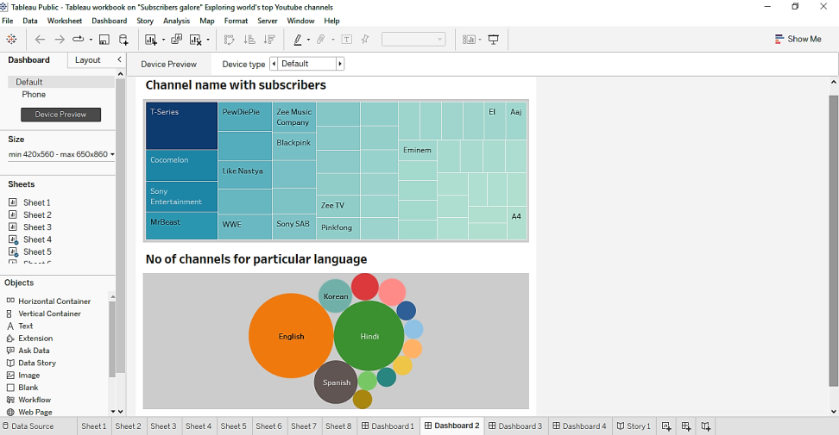

Country wise subscribers and Language wise subscribers

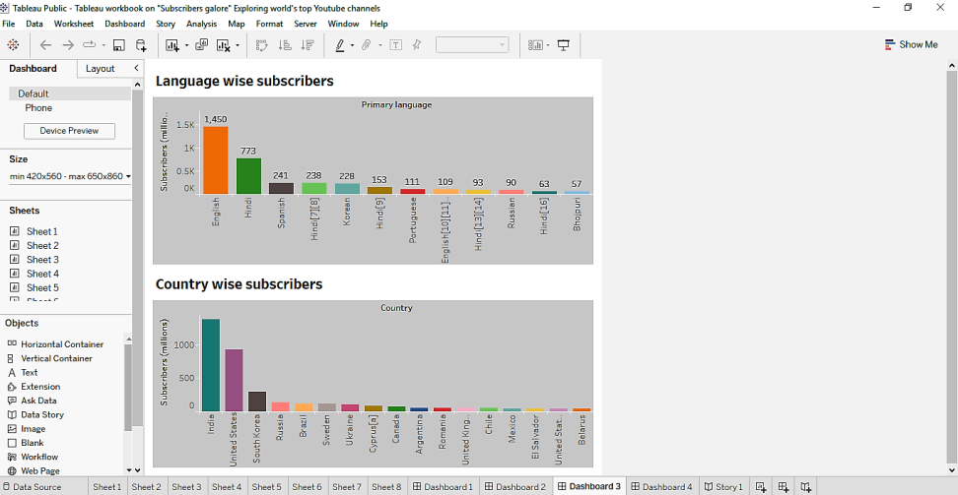

Country wise subscribers

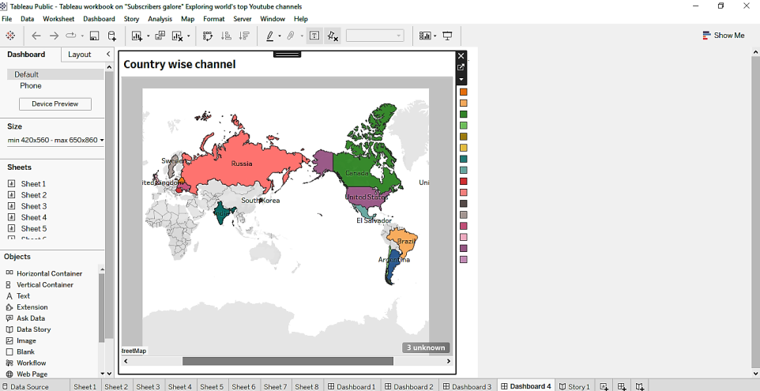

Story

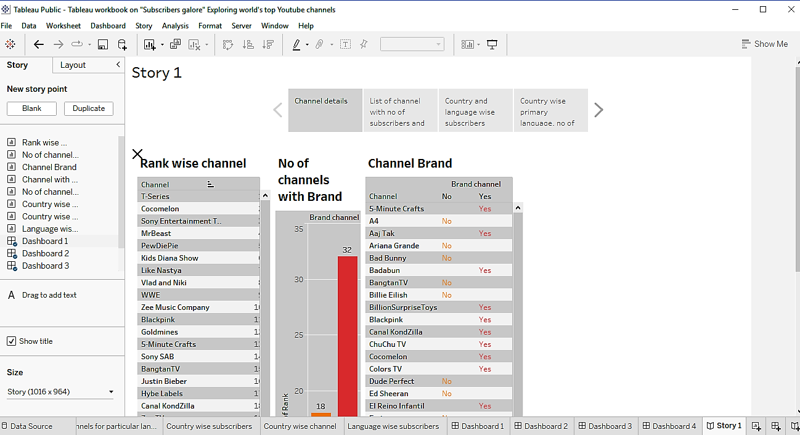

4. Advantages and disadvantages:

* So many graphs , dashboards and stories can be created. Because of this, the data can be easily analyzed
* We could know about World’s top YouTube channels.
* Duration of tableau is very short (14 days).

5. Conclusion:

Finally the processes which have been done by my team is published on tableau. The video of our project is demonstrated. The project report is given above. We gave a clear dashboards and story which are to be easily understood.

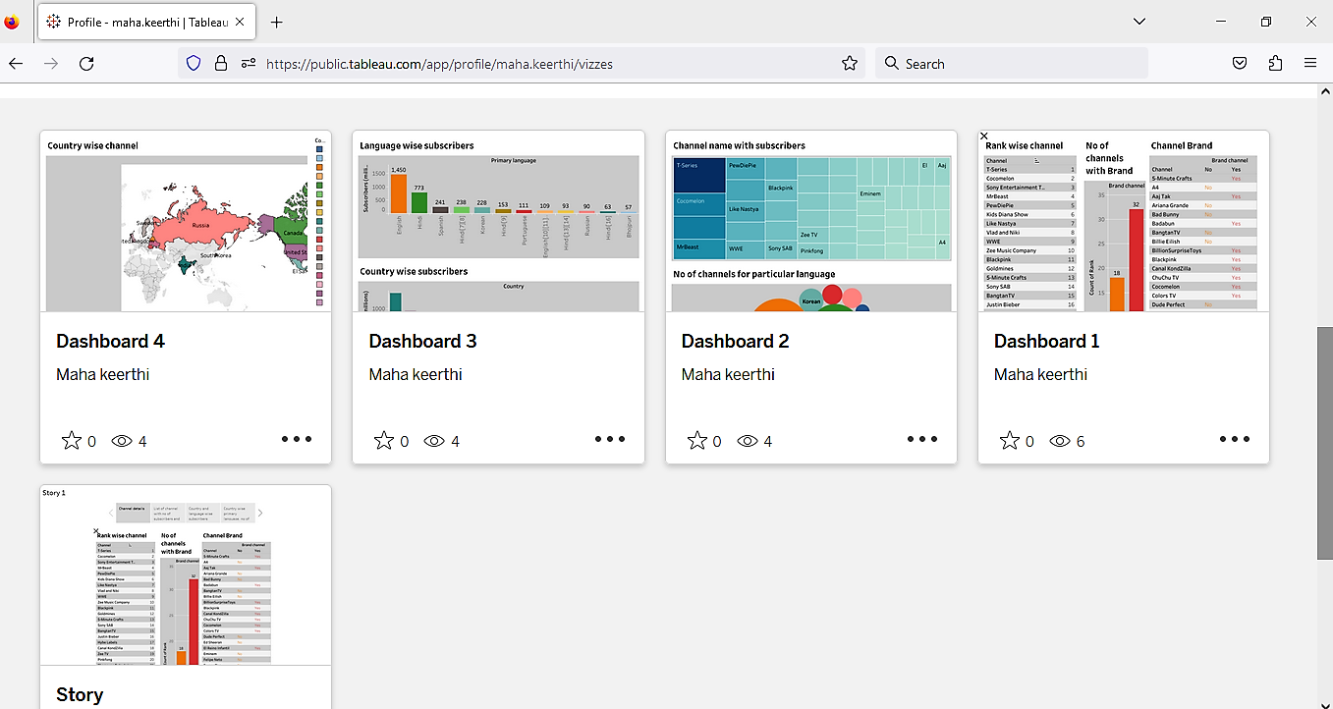

6. Future scope:

This project gave us a guidance to get a job related to this field in our future in a software companies. We may be analyzers in our life.